**Seabird Behaviour**

A Biology Programme for

Secondary Students

at the **Royal Albatross Centre**

###### Programme Booklet for Teachers

###### 2022

**Programme Overview**

**Objective:** To view seabirds breeding at Taiaroa Head, investigate seabird behaviour in response to their external environment, discuss breeding behaviour (courtship and pair bonding) and migration.

**Programme Description:** Investigate behaviour of shags and albatross in response to their external environment. Courtship and parental care are some of the behaviours which the programme focuses on. Discussion follows on the use of behavioural studies in management.

Time: 2 hours

Age Focus: Year 13

## Curriculum Area: Biology 3.3, AS 91603

Cost: $4/person

### Spend the day on Otago Peninsula

**New Zealand Marine Studies Centre:**

There are a number of connecting programmes available at the NZ Marine Studies Centre and Aquarium. For programme details and bookings check out [www.marine.ac.nz](http://www.marine.ac.nz/)



**Standard Programme Plan:**

|  |  |
| --- | --- |
| **Time** | **Activity** |
|  | Arrive, meet guide at reception   * *please arrive 10 minutes early* |
| 0 min | **Education Rm** (30 min)   * *Features of an Albatross* * *Overview of breeding cycles& behaviours* * *Programme objectives* |
| 30 min | **Observatory** (30 min)   * *Albatross viewing* * *Otago shag viewing* * *Recording of observations* * *Comparative behaviours* |
| 1 hour | **Cliff Area & Displays** (30 min)   * *Viewing of Spotted Shags* * *Recording observations* * *Comparative behaviours* |
| 1.5 hr | **Education Rm** (30 min)   * *Albatross Behaviour Video* * *Discussion and wrap-up* * *Hands-on-Head game* |
| 2 hours | **Depart** |

# Curriculum Links and Planning Guide

**Biology 3.3, AS 91603**

**Demonstrate the understanding of the responses of plants and animals to their external environment.**

Specific information for individual external achievement standards.

Students are introduced to the following terms and are able to observe many of the following behaviours during the programme:

Cooperative breeding

Courtship

Home range

Biological clock

Students are introduced to graphical and tabulated data.

### Tour Guidelines

1. **Supervisors**

* Role of supervisors is to:
* ensure that the students act in a responsible manner.
* assist the students with the activities.
* keep the noise level down and the group together.

1. **Dress warmly**

* It is always windy and cold at Taiaroa Head.

1. **Arrive 10 Minutes Early**

* If you are late, the time of your visit may be cut short as the observatory time is fixed and other tours are scheduled immediately after yours.
* Please allow time for a toilet break before the programme begins.

1. **Group Size**

* Please note only 25 people are allowed in the observatory at once.
* Please organise your students and supervisors into groups of 25 or less before arrival.

1. **Programme Length**

* The programme is 2 hours long (includes 15-30 minutes in the Richdale Observatory).
* Please plan to have morning or afternoon tea before or after the programme (not during).

1. **Lunch Areas**

* Areas suitable for lunch include:
* Pilots Beach platform
* Grassy area to the east of the Royal Albatross Centre.
* Education Room maybe available if the weather is wet (please check availability with Royal Albatross Centre staff in advance).

##### Shop and Cafeteria

* Please keep students out of these areas unless they are planning to make a purchase.

##### No Smoking

* To reduce the fire risk to the colony, smoking is not permitted.

**Pre-trip Preparation**

In order to ensure that students get the most out of the programme we suggest that some pre- and post-trip work is done in the classroom prior to the visit to the Royal Albatross Centre.

1. **Risk Assessment**

Review guidelines on the web site and review with trip supervisors.

(<http://www.albatross.org.nz/education/educational-resources/> )

1. **Pre-trip Activities**

Use the activities on the web site and the resources listed to introduce the students to albatross and the Taiaroa headland.

1. **Background Information**

Review the information provided in this booklet. Further information about albatross and the Taiaroa Headland site can be found on the web site and in the reference list

1. **Work Sheets**

Programme worksheets are attached and available on web site. Please make copies for your students as they will be used during the programme. Answer sheets are also attached to help with follow-up in the classroom.

1. **Tour Guidelines**

Please review the Tour Guidelines with your students and supervisors prior to the trip to the Royal Albatross Centre.

1. **Teacher led activities at Taiaroa Head**

Extend your visit to Taiaroa Head by exploring the headland. Identification guides will help you find other species of birds and mammals that use the headland.

1. **New Zealand Marine Studies Centre**

Combine at the Royal Albatross Centre programme with a visit to the NZ Marine Studies Centre and Aquarium.Spend the morning at the Aquarium and the afternoon with the Albatross or vice versa. The programmes are complementary and together create a unique learning experience for your class.

**Resources**

##### Royal Albatross Centre Activity Sheets

**Download from** [**http://www.albatross.org.nz/education/educational-resources/**](http://www.albatross.org.nz/education/educational-resources/)

**SECONDARY**

##### Seabird Behaviour Worksheets

##### These worksheets follow the programme objectives and look at behaviours of Royal Albatross, Otago Shags and Spotted Shags.

##### ALL LEVELS

**Human Impact Trail**

A self-guided walk down to Pilots Beach to look at human impact on the sight.

##### Plastic Breakdown Poster

Information on how our plastic rubbish is affecting wildlife in dramatic ways.

**Relevant Web Sites**

[www.albatross.org.nz/education/educational-resources/](http://www.albatross.org.nz/education/educational-resources/) The education part of the Royal Albatross Centre website. Lots of activities and information to download.

[www.albatross.org.nz](http://www.albatross.org.nz/)

The Royal Albatross Centre site with background information on the colony and history of Fort Taiaroa.

[www.doc.govt.nz/get-involved/conservationeducation/resources/seabirds/](http://www.doc.govt.nz/get-involved/conservation-education/resources/seabirds/)

Southern Seabird Solutions fact sheets and lesson plans

Excellent resources

[www.savethealbatross.net](http://www.savethealbatross.net/)

Save the Albatross campaign by RSPB and Birdlife International.

[www.forestandbird.org.nz/saving-our-environment/marine-and-coastal/save-our-seabirds](http://www.forestandbird.org.nz/saving-our-environment/marine-and-coastal/save-our-seabirds)

Facts about the threatened albatross species and information on the campaign to prevent albatross deaths in the fishing industry.

[www.wwf.org.nz/what_we_do/species/seabirds/](http://www.wwf.org.nz/what_we_do/species/seabirds/)

World Wide Fund for Nature site with information on conservation issues surrounding albatross.

[www.albatrossencounter.co.nz/albatross/great_albatross/](http://www.albatrossencounter.co.nz/albatross/great_albatross/)

A tourism operation in Kaikoura. Has a conservation section and information on what birds (including albatross) can be seen.

<http://science.howstuffworks.com/great-pacific-garbage-patch.htm>

How stuff works articles on the problem the Pacific Ocean is facing with plastics and how we can ‘potentially’ clean it



**Seabird Behaviour**

A Biology Programme for

Secondary Students at the **Royal Albatross Centre**

**Student Worksheets**

2022

**Seabird Behaviour – Activities**

**Northern Royal Albatross - Toroa**

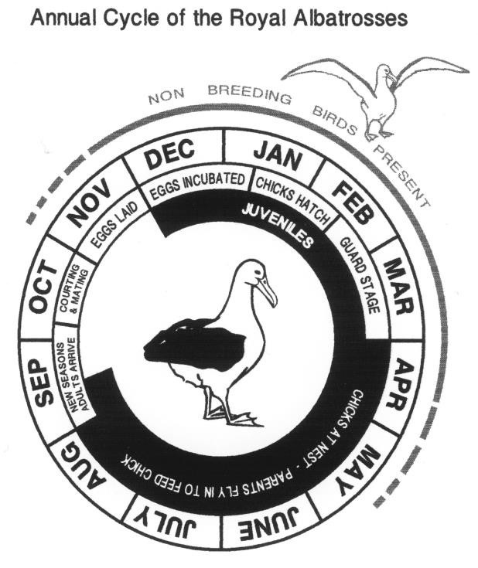

*Diomedea sanfordi*

• white body, black on backs of wings

• feeds on surface shoaling fish and squid

• male and female equal share in rearing 1 chick every 2nd year

• mature at 6 years - live about 30 years

• mate in October 1 egg laid in

November

• incubation 79 days

• chick guarded for the first 6 weeks

• young depart late September

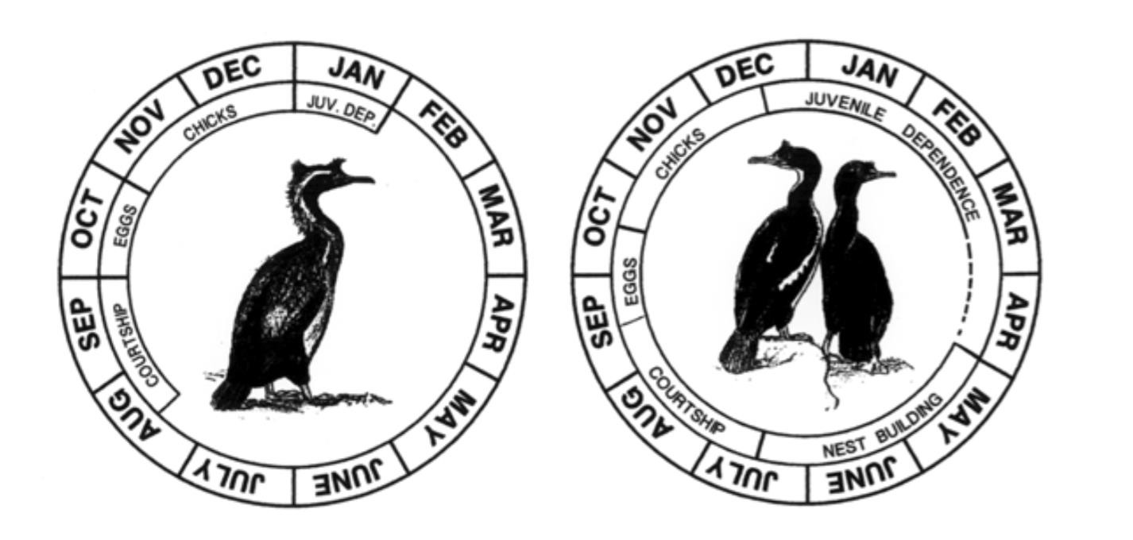

Annual Cycle of the Spotted Shag Annual Cycle of the Otago Shag

**FEATURES AND ADAPTATIONS OF A SEABIRD**

1. Albatross spend 86% of its life at sea. What adaptations do they have that makes them a seabird? Identify the 5 key features of an albatross and explain how each feature helps them adapt to life at sea.

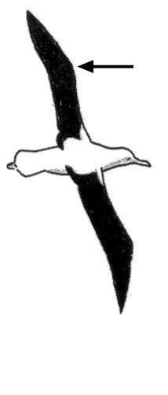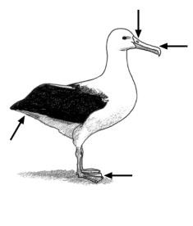

*Oil gland – waterproofing feathers, salt gland / nostrils – excreting excess salt , hooked bill – catching prey like squid , webbed feet – swimming, taking off from water surface, 3m wingspan with double fold – dynamic soaring and folds away neatly*

2. If albatross spend most of their time at sea, why do albatross come to land and what considered as an ideal nesting site?

*Windy weather – northly and southerly, nearby foraging grounds, grass for nesting*

**ANNUAL CYCLE OF ALBATROSS**

3. The breeding behaviors of animals are influenced by abiotic and biotic factors.

What are some examples of abiotic and biotic factors that affect the breeding behaviors of the albatross? Give examples below:

|  |  |
| --- | --- |
| Abiotic factors | Biotic factors |
| *Weather*  *Temperature*  *Humidity* | *Predators*  *Other albatross*  *Interspecific competition with other wildlife* |

4. Based on the weather (abiotic conditions) and the time of year (annual cycle) – what behaviours would you expect to observe today for the albatross?

**TRACKING ALBATROSS: HOMING AND MIGRATION**

5. Seabirds are great navigators. Homing and migration are two common movements across both involve the ability to navigate their way “back home again”. How does migration differ from homing behavior?

|  |  |  |
| --- | --- | --- |
|  | Homing | Migration |
| Travel distances | *short* | *long* |
| Travel time | *Daily/every few days* | *Annually, once in lifetime* |
| Travel period | *short* | *long* |

Over the years scientists were able to use GPS to track the navigation behaviour of the albatross. Look at the maps and answer the following questions:

6. The maps shown below are the total flight paths of two parents (LGK & LGL) during the first half of their breeding season (11/02/21 -30/04/21):

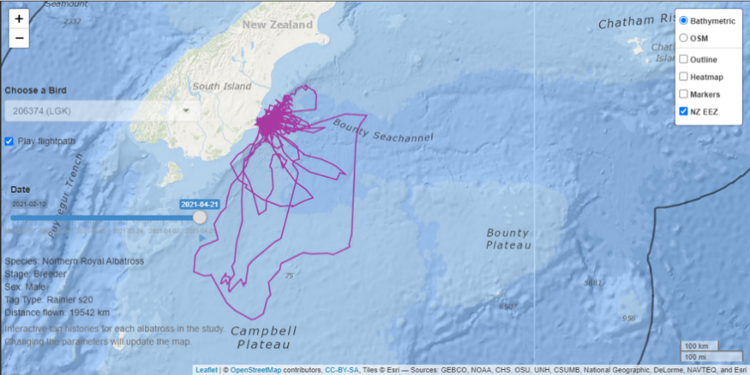

1. Is this behaviour migration or homing?

*Homing*

1. Where on the map does each parent spent most of their time (look for overlapping lines)

*Chatham rise, below South Island, Otago coast*

1. Does the bathymetry of the sea affect their foraging route? If so, how?

*Shallower areas along Chatham rise, off continental shelf*

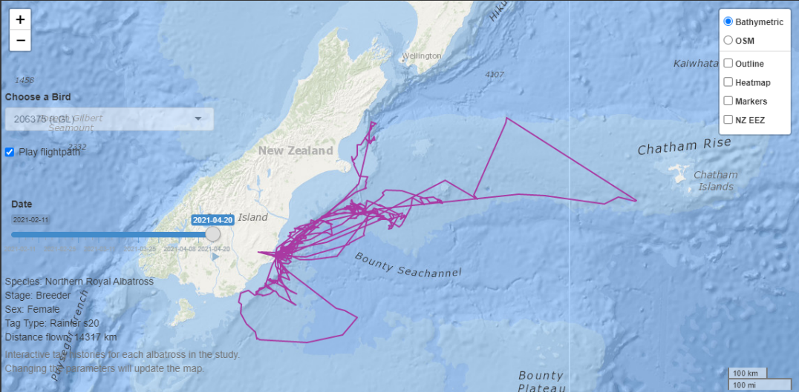

7. (Reading): Below is GPS tracking of four juveniles back in 2008 – 2009. Read through the paragraph and the maps and answer the questions below:

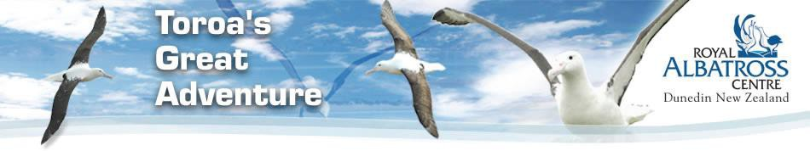

Each of the birds had lightweight satellite transmitters attached to their back feathers and GPS locations were given every 6 hours and the data was plotted onto Google Earth Maps for visitors to our web- site to view. These birds were tracked for approximately one year.

All four albatrosses are currently no longer transmitting. We may never know the reason for this, but speculations include detachment of the transmitter (due to natural wear and tear of moulting of the feathers), malfunction, or mortality of the albatross. However, if these albatrosses return to the colony as expected in the years to come, it may be possible to ascertain the reason.

**Journey**

They appeared to head north from Taiaroa Head up the coast of NZ. From here they travelled

across the Southern Ocean in and almost straight line, taking between 11 and 80 days to reach the coast of Chile from NZ waters.

The speed of the albatrosses ranged between 105 and 110 km/hr and the altitude was approximately 37m above sea level. The average daily minimum distance travelled ranged from 500km to just over 1000km and the total maximum distance travelled during the tracking period was 46,000km.

Oceanic and environmental data will be analyzed with location data to find possible behavioural patterns as well as travel routes and ocean hotspots used by the Northern Royal Albatross and the time of the year used.

Understanding where the Albatrosses go at every stage of its life is important in identifying possible reasons for population decline and possible management plans can be developed to aid the growth of the colony.

Toroa (55028) – last data received Sep 2008

Juvenile Female (55027) – last data received Aug 2008

Juvenile Male (55029) – last data received Feb 2008

Adolescent Male (88071) – last data received May 2009

1) Why is information from GPS tracking important when studying animal behaviour?

|  |
| --- |
| *Learn about foraging grounds – overlapping with commercial fishing grounds.*  *Learn about migration patterns to understand species better.* |

2) Juvenile Female (55027) took about __*30*___ days to travel from Taiaroa Head to Chile.

3) Is this behaviour homing or migration? __*migration*______

4) Why do you think non-breeding birds go to Chile? _____*foraging grounds*________

5) Adolescent Male (88071) was tagged in early January, and he spent the first month venturing up to 150-300km from Taiaroa Head, returning every 1-2 days. Is this behaviour homing or migration? ___*homing*_____

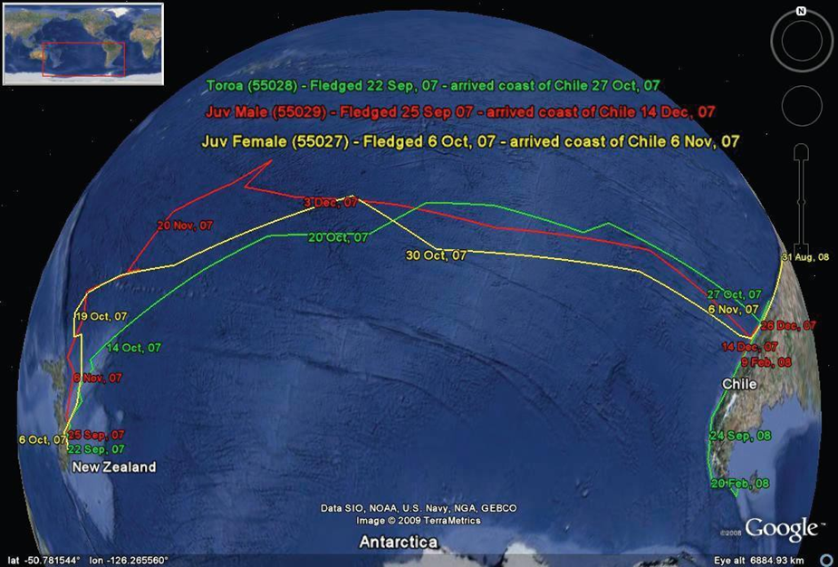

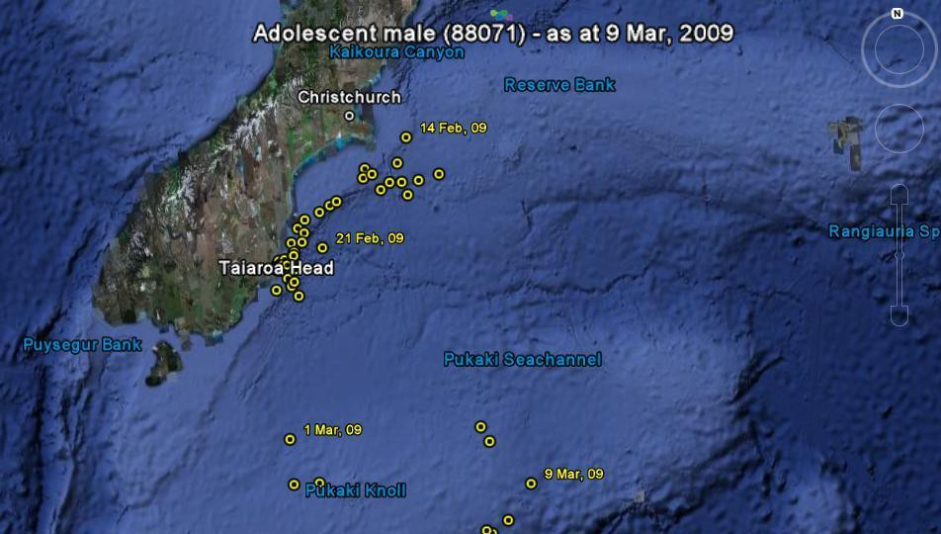

**THE USE OF WILDLIFE LIVECAMS**

The study of animal behaviour requires careful and lengthy observation. With the advancement of camera technology and interne access, we are given great opportunities to learn and gather valuable information from wildlife. The first Royal Cam was launched in 2016 and is a 24/7 live stream of an albatross nest at Taiaroa Head during the breeding season. Since 2016 it has received more than 2.5 million views globally.

8. What are some benefits of using a webcam tool to study animal behaviour?

|  |
| --- |
| *Non-invasive way to study, accessed worldwide at any time of day, real-time activity, increases community engagement and understanding.* |

9. Royal Cam also allows us to learn about the parental care of the albatross. Watch the following highlights from Royal Cam with your educators and answer the questions below:

Video 1: Royal Cam 2016 Highlights - Chick being fed by Dad

1. What term is used to describe this feeding behaviour? *crossbill regurgitation*
2. Do both parents feed chicks? *yes* How long for? *eight months, until chick fledges*

Video 2: Royal Cam 2017 Highlights - Parents swap over nest duties

1) What is the difference between the guard stage and post-guard stage?

*Guard stage – chicks guarded full-time by one parent, post-guard – chick alone at nest*

3) When do parents stop guarding chicks? *post guard is end of March ~6 weeks old* ___________________________

10. Are albatross r-selected species or k-selected species, explain why?

|  |
| --- |
| *k-selected – long lived, high parental investment, fewer offspring, delayed sexual maturity* |

|  |  |  |  |  |
| --- | --- | --- | --- | --- |
| Comparative Behaviours – use the displays, videos and viewing areas to investigate behaviours listed and answer questions | | | | |
| Behaviour | Royal Albatross (Adult) | Royal Albatross (Chick) | Otago Shag | Spotted Shag |
| COMMUNICATION  Courtship displays  (advertising – finding a mate) | When albatross return to Taiaroa Head in the spring, they are often seen sky calling with their bill pointed to the sky and wings extended.  What other behaviours are involved with this courtship dance?  *Sky calling, wing displays, head bowing, bill tapping/clicking* | How would this courtship behaviour increase the chance of successful mating to produce viable offspring?  *Shows good genes, ability to maintain their feathers/appearance, shows reliability and commitment to mate* | To advertise to potential mates during courtship, the males display a range of behaviours for 2-3 months including:   * Head waves (darts) * Expose colourful plumage on face * Vocalization * Wings frozen in open position * Body held upright | In spotted shags, the courtship dance is called a wing waving display which continues for 2-4 weeks.  How do you think the courtship dance in the spotted shags differ from the Otago shags?  *Spotted shags wave and flutter their wings* |
| COMMUNICATION  Pair bond display  (recognition – keeping a mate) | In addition to sky calling, what behaviours are observed during the pair bond display?  *Mutual preening, cuddling, sitting together, nest contribution* | How do chicks recognize and communicate with their parents?  *Calling – vocalizations are recognizable as with many species of animals* | Mutual head lowering is a key feature of the Otago shag pair bond display.  This is only seen closer to the breeding season later in the year. | The spotted shag pair bond display is slightly different to Otago shags and includes mutual darting, pointing, and bowing. |

|  |  |  |  |  |
| --- | --- | --- | --- | --- |
| Behaviour | Royal Albatross (Adult) | Royal Albatross (Chick) | Otago Shag | Spotted Shag |
| COMPETITION  (intraspecific – within the same species)  Nest territory and aggression | Are the nests spaced evenly?  *Sporadically spaced ~25m*  How do they react to another adult albatross near their nest?  *Territorial, defend nest site* | How does the nest territory at the Chatham Islands differ?  *Much more densely packed*  What are they competing for?  *Space, food, nesting materials* | Are the nests spaced evenly?  *Yes ~1m pecking distance*  How do they react to another adult near their nest?  *Territorial, will peck* | Are the nests spaced evenly along the cliff edge?  *Sporadic along ledges*  How do they react to another adult near their nest?  *Territorial, will fight off* |
| COMPETITION  (interspecific – between different species)  Predators | Do they compete with other species on the headland for nest sites?  *No, maybe only a few blue penguins*  What are the predators of the adult albatross and how do they defend themselves?  *Natural predators are sharks at sea, potentially vulnerable to mammalian predation such as rats, stoats, cats but more likely as chicks, use bill* | What are the predators of the albatross chicks and how do they defend themselves?  *Cats, stoats, rats. Chicks can spill oily vomit or clack bill*  How does DOC control predators?  *Predator traps mainly for stoats and cats, rabbit bait, exclusion fence mostly for people* | Nests are within pecking distance.  Do they compete with any other species on the headland for nest sites?  *Not really, confined to cliff side below observatory* | Why does the cliff face make such a good nesting site?  *Difficult for mammalian predators to access nest sites* |

|  |  |  |  |
| --- | --- | --- | --- |
| Behaviour | Royal Albatross (Adult) | Royal Albatross (Chick) | Otago and Spotted Shags |
| FEEDING | The main diet of albatross is squid – how do they catch it?  *Hooked bill, surface feeders* | Chicks are dependent on parents for food – how do they trigger adults to regurgitate?  *By tapping parents bill, the blood vessels in parents bill dilate after chick hatches – this is very sensitive to tapping induces regurgitation.* | Unlike albatross, shags are diving birds.  They tend to feed mostly on shoals or schools of fish 20-30 metres below the surface. |
| THERMO-REGULATION  Cooling and conserving heat | How do albatross cool down?  *Panting, drinking water including sea water, standing to expose feet* | Why are chicks vulnerable when exposed to high temperatures?  *Cannot move/leave headland, must wait for parents to bring food/water* | Shags thermoregulate by holding their wings out, exposing their feet and drinking sea water. |
| MOVEMENT  Flying and walking | Describe dynamic soaring?  *Fly into wind to gain height, fly down with wind to gain speed. Sideway “S” shape along surface of water. Very aerodynamic and energy efficient.* | Are young chicks very mobile?  *Chicks are fairly immobile for first couple months, gain more strength through winter months and can move more easily by June/July* | Describe how shags fly?  *Rapid flapping of wings, expend more energy. Often fly in groups.* |

Extra questions

DIVORCE IN SEABIRDS

11. Seabirds like albatross and shags tend to be monogamous, but occasionally a pair will divorce and re-pair with a new mate if one is lost or is unreliable. Outline one positive and one negative of a pair divorcing:

|  |  |
| --- | --- |
| Positive | Negative |
| *May find more suitable mate, increase productivity* | *Lost breeding years, new mate could be less suitable* |

HUMAN IMPACTS ON BREEDING BEHAVIOUR

Many factors can influence both the breeding behaviour and the chance of success including human behaviour, climate change, and plastic pollution.

12. How does climate change affect breeding behaviour in seabirds?

Think about warming ocean temperatures, food availability etc.

*Less food available, increased stress when foraging and raising chicks, increased stormy weather events*

13. How does plastic pollution affect the feeding behaviour and breeding success of albatross and other seabirds?

*Plastic pollution increases risk of starvation and choking, reducing chance of chick’s survival*